Broken Blackjack

Lab # 7

BY

Corey Henry

Cah835

***“On my honor, as a Mississippi State University student, I have neither given nor received unauthorized assistance on this academic work.”***

***Signature X__________________________***

CSE1284 Introduction to Computer Programming

Class Section # 1

Josh Crowson  
Oct 15, 2014

Problem: Take the code given and fix it, so the game runs properly

Solution: fix spacing and logic errors and rename variabels so that they make sense.

Questions: what is a easier way other than taking each line of code back a space to help fix spacing issues without crashing or ruining all the lines of codes? The code does not fully follow the rules of blackjack, to account for splitting and for an Ace accounting for 1 or 11, what kinds of code could we use to change this? A lot of the cards we used suits, but there was a error written into the code to say the suits didn’t match and im not sure why that code was there unless it was a type of validation loop.

Sample Execution:

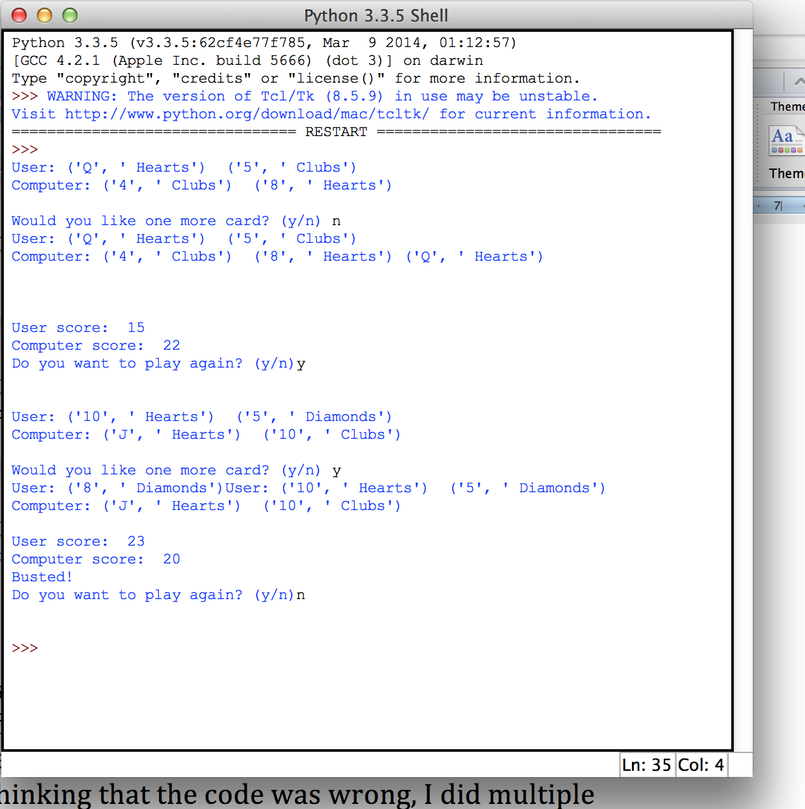

Analysis and conclusion: This lab was very difficult mostly due to the spacing errors. I was able to get rid of the majority of the spacing problems so that the problem would run, but unknowingly there were still a few more spacing problems that caused different errors in my code. Thinking that the code was wrong, I did multiple changes to the code with zero to no result only making the code more broken. After discovering the spacing problem I had to go back to the original code and change my code back in some places to fix the changes I had made. The majority of problems I had were the player automatically getting a 3rd card, or when the player got another card it would add the cards score but it would not display the card they had received.

Code:

import random

def main():

#start game automatically

play_again = 'y'

if play_again == 'y':

#get random card values for the player and computer

user1 = random_card()

user2 = random_card()

user3 = -1

computer1 = random_card()

computer2 = random_card()

computer3 = -1

print("User:", get_card_value(user1), "", get_card_value(user2), end='')

#if statement if they user wants another card and if computer gets one

if user3 != -1:

print("User:",get_card_value(user3), end='')

if computer3 != -1:

print("", get_card_value(computer3), end='')

print("\nComputer:", get_card_value(computer1), "", get_card_value(computer2), end='')

# print new line

print("\n")

#tally up the scores for the user and computer

userscore = second_hand(user1, user2, user3)

computerscore = second_hand(computer1, computer2, computer3)

#prompt user for another card

user3 = another_card()

userscore = second_hand(user1, user2, user3)

#if user got another card then excute to print it

if user3 != -1:

print("User:",get_card_value(user3), end='')

#if the user is winning and under or equal to 21 computer gets another card

if(userscore > computerscore and userscore <= 21):

computer3 = random_card()

print("User:", get_card_value(user1), "", get_card_value(user2), end='')

print("\nComputer:", get_card_value(computer1), "", get_card_value(computer2), end='')

if computer3 != -1:

print("", get_card_value(computer3), end='')

print("\n")

computerscore = second_hand(computer1, computer2, computer3)

print('\n')

print("User score: ", userscore)

print("Computer score: ", computerscore)

#if the user goes over 21 print he busts

if userscore > 21:

print("Busted!")

#if the scores match it's a tie

elif userscore == computerscore:

print("It's a tie")

#if computers score is higher than you loose

elif computerscore <= 21 and computerscore > userscore:

print("Sorry. You lost!")

#if computer score is lower than you win

elif userscore <= 21 and userscore > computerscore:

print("Congratulations! You won.")

#ask if they want to play again

play_again = input("Do you want to play again? (y/n)")

print('\n')

# if they dont enter y or N

while play_again != 'y' and play_again !='n':

print("Please enter only a 'y' or 'n'")

play_again = input("Do you want to play again?")

if play_again == 'y':

main()

#get a random card

def random_card():

return random.randint(0,51)

#determine the value of the card

def get_card_value(card):

#change value for face cards

faceValue = int(card / 4) + 1

suit = card % 4

if faceValue == 0:

faceValue = ""

elif faceValue == 1:

faceValue = 'A'

elif faceValue == 11:

faceValue = 'J'

elif faceValue == 12:

faceValue = 'Q'

elif faceValue == 13:

faceValue = 'K'

else:

faceValue = str(faceValue)

#determine the suit of the card

if suit == 0:

suit = " Clubs"

elif suit == 1:

suit = " Diamonds"

elif suit == 2:

suit = " Hearts"

elif suit == 3:

suit = " Spades"

else:

suit = ""

print("Error! Bad suit")

return (faceValue, suit)

def second_hand(card1, card2, card3):

score = 0

faceValue1 = int(card1 / 4) + 1

faceValue2 = int(card2 / 4) + 1

faceValue3 = 0

if card3 != -1:

faceValue3 = int(card3 / 4) + 1

if faceValue1 == 0:

score1 = 0

elif faceValue1 == 1:

score1 = 11

elif faceValue1 == 11 or faceValue1 == 12 or faceValue1 == 13:

score1 = 10

else:

score1 = faceValue1

if faceValue2 == 0:

score2 = 0

elif faceValue2 == 1:

score2 = 11

elif faceValue2 == 11 or faceValue2 == 12 or faceValue2 == 13:

score2 = 10

else:

score2 = faceValue2

if faceValue3 == 0:

score3 = 0

elif faceValue3 == 1:

score3 = 11

elif faceValue3 == 11 or faceValue3 == 12 or faceValue3 == 13:

score3 = 10

else:

score3 = faceValue3

score = score1 + score2 + score3

return score

def another_card():

answer = input("Would you like one more card? (y/n) ")

while answer != 'y' and answer != 'n':

print("Please enter 'y' or 'n'")

answer = input("Would you like one more card? (y/n) ")

if answer == 'y':

return random_card()

else:

return -1

main()